# Introduction

The Blister Pack Opener is intended to make it easier to remove medication (e.g., pills) from blister packs. This may be useful for people with limited hand strength or dexterity, such as those with arthritis.

# Research

## Commercial Options

Existing commercial solutions were found by doing a web search for ‘Pill Opener’ and ‘Blister Pack Opener’.

|  |  |  |  |  |
| --- | --- | --- | --- | --- |
| Name |  | Picture | Price | Link |
| Blister Pack Opener |  |  | Not Available | [Link](https://at-aust.org/items/6725#:~:text=A%20small%20round%20plastic%20device,the%20pills%20from%20the%20pack.) |
| Pill Ejector |  |  | $7.79 | [Link](https://www.ocelco.com/store/pc/Pill-Ejectors-c1835.htm) |
| Easy Open Pill Popper Tool |  | Easy Open Pill Popper Tool | $8.90 | [Link](https://www.healthpride.com.au/product/Easy-Open-Pill-Popper-Tool/1876) |
| Tablet Puncher – Blister Opener |  | Tablet Puncher - Blister Pack Opener Tablet Popper Remover with Container 5055952478426 | eBay | n/a | n/a |
| Pirucare – blister pack opener |  | Pirucare - blister pack opener | Discontinued since 31-10-2016 | [Link](https://hmi-basen.dk/en/r11x.asp?linkinfo=36111) |
| Pill Handle |  |  |  | [Link](https://www.livetsomsenior.dk/pillehandtag) |
|  |  |  | $32 | [Amazon Purchase Page](https://www.amazon.ca/Celiy-Arthritis-Dispenser-Housekeeping-Organizers/dp/B089652RNK) |
| Pillmate Pill Punch |  |  | $13, low stock | [Pillmate Pill Punch - Amazon](https://www.amazon.ca/Shantys-PillMate-PillPunch-Random-Colour/dp/B001KUA220) |

## Existing DIY Options

|  |  |  |  |  |
| --- | --- | --- | --- | --- |
| Name |  | Picture | Price | Link |
|  |  |  |  |  |
| Pill Puncher |  |  | N/A | [Link](https://cults3d.com/en/3d-model/tool/pillikan-easy-to-print-pill-puncher) |
| Pill Puncher |  |  | N/A | [Link](https://www.thingiverse.com/thing:1630353) |
| Blister Pack Opener |  |  | N/A | [Link](https://www.thingiverse.com/thing:3080416) |
| Blister Tablet Opener |  |  | N/A | [Link](https://www.thingiverse.com/thing:2846756) |
|  |  |  |  | [Link](https://www.thingiverse.com/thing:2711263) |
|  |  |  |  | [Link](https://www.thingiverse.com/thing:2926687) |
|  |  |  |  | [Link](https://www.thingiverse.com/thing:2425976) |

# Requirements

## Goals

|  |  |
| --- | --- |
| G01 | The device must make it easier to remove items from blister packs by reducing the required dexterity or required force or both. |
| G02 | The device should work with a range of pill shapes and sizes. |
| G03 | The device should make it less likely to lose the pill. |

## Functional Requirements

|  |  |
| --- | --- |
| F01 | The device must be operable with one hand. |
| F02 | The device should allow for opening blister packs using force generated by the whole hand. |
| F03 | The device should allow for opening blister packs with minimal force |
| F04 | The device must have a means from preventing the pill from getting lost. |
| F05 | The device must provide enable the user to easily retrieve the pill after its removed from the blister pack. |
| F06 | (Range of pill sizes) |
| F07 | (Number of cycles to failure) |

## Non-functional Requirement

|  |  |
| --- | --- |
| NF01 | The device should be printable with no supports |

## Constraints

|  |  |
| --- | --- |
| C01 | Should be entirely 3D printed |

# Existing Devices

## Pill Release for Blister Packs

<https://www.thingiverse.com/thing:5572151>

Author: Elppa8

License: Creative Commons - Attribution

Cost: 12g of filament

Print Time: 1h40min

### Summary

A cup with a large fin coming out of the centre. The fin can be used to remove the pill from the pack, which then falls into the cup.

### Print Testing

Device printed easily with no supports

### Functional Testing

Unintuitive on how to use. Broke when opening a gum blister pack.

### Opportunities for Improvements

Fin can be improved to withstand more torque.

## PILLIKAN - EASY TO PRINT PILL PUNCHER

This design is comprised of a single 3D printed piece. It utilizes a flexure hinge. The pill is pushed into a compartment oriented towards the side of the device.

Author: Brignetti Longoni

License: Creative Commons Attribution

Cost: 20g filament

Print Time: 3h22min

### Print Testing

The print was tested on its side with no supports and printed with no issues

### Functional Testing

Device was used to open a Day-Quil Pack and a gum package, as those were the only blister packs on hand. It was found that both packages were too large to fit through the hole on the print.

Closing force: ~150 gf

### Opportunities for Improvements

* Handle could be made stiffer to transfer force better without bending
* The handle could have a slight curve to make it fit the hand better
* Sharp edges can be made smoother
* Mouse ears can be added to prevent the print from peeling

## Blister pack opener

(Summary)

Author: Joep Welling

License: Creative Commons - Attribution - Share Alike

Cost: 32g of filament

Print Time: 4h32min

## Pill Puncher

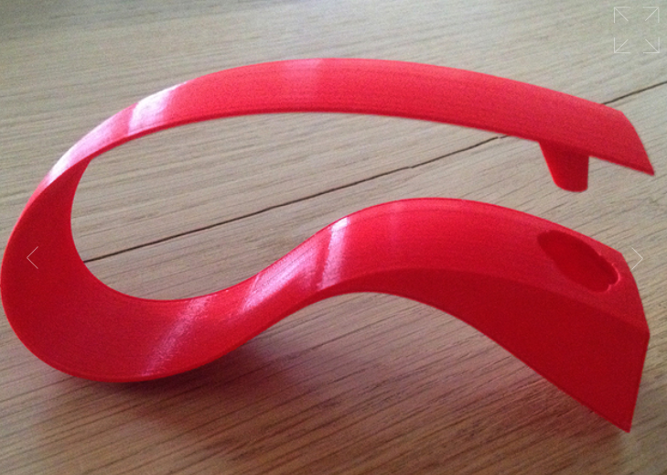

Author: Ivery Barel

License: CC-BY-NC-ND

Cost: 21 g of filament

Print Time: 3h11min

### Summary

This design is comprised of a single 3D printed piece. It utilizes a flexure hinge. The pill is pushed into a compartment oriented towards the front of the device.

### Print Testing

The print was tested on its side with no supports and printed with no issues

### Functional Testing

This design also tend to cause the pills to fly out of the pocket and out the end of the device. Some users have reported that this design tends to crack where the pills come out.

Closing force: ~200 gf

### Opportunities for Improvements

* The design has sharp corners along the handle and on the ends of the handle.
* The pill compartment section could have additional material added to resist the force applied by the ejector and reduce the likelihood of cracking
* The handle portion may not be stiff enough, so that the device doesn’t work well unless the user applies force directly over the ejector pin. A rib or additional material could be added to stiffen this section.
* Add a mouse ear to the end of the handle so the print is less likely to warp

### Conclusion

## Blister Pack Pill Popper

<https://www.thingiverse.com/thing:2711263>

Author: M Craig

License: Creative Commons - Attribution - Non-Commercial

Cost: 2g of filament

Print Time: 15min

### Summary

Design consists of two roughly half circle shaped tabs connected by a thin piece of plastic. One tab has a horn to push out the pill, and the other tab has a hole to allow the pill to be removed. The design allows the user to apply force over a larger area.

### Print Testing

Design printed quickly with no supports

### Functional Testing

No pills small enough to test with. The thin connecting piece of plastic had to be bent while still hot and quickly developed fatigue lines.

### Opportunities for Improvements

A more flexible filament could be used for the connector

## Comparison

## Pill Opener

<https://www.thingiverse.com/thing:5780009>

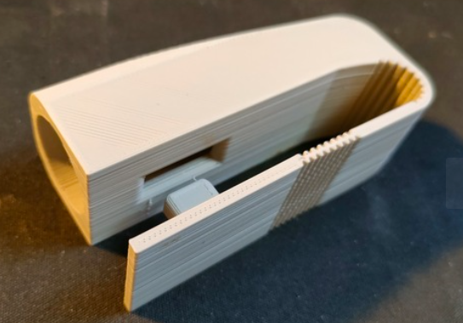

Author: Daniel Walsh

License: Creative Commons - Attribution - Non-Commercial - Share Alike

Cost: 36 g of filament

Print Time: 5:46

# Testing

The device was tested on various blister packs, it worked well on smaller pills, but was too small to accommodate Day-Quil blister packs.

# Opportunities for Improvement

The hole could be made larger to accommodate for larger pills.

Add tactile indication of where user should put thumb

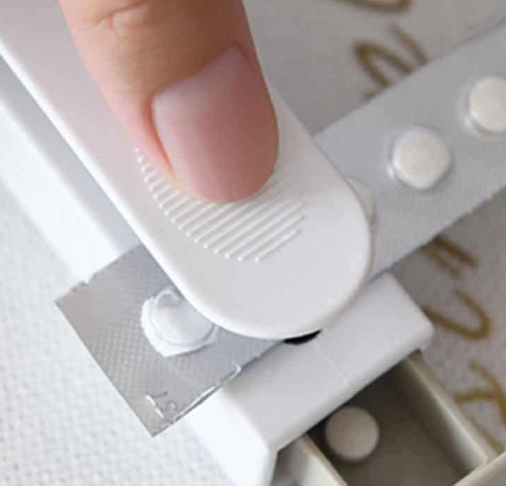

# Design

## Design 0.1

### Summary

This design is similar to the Pill Puncher by Ivery Barel. The pill pocket opens towards the front.

### Functional Testing

The design felt comfortable in the hand. The handle is significantly stiffer and requires greater force to close.

The puncher successfully removed the pill from the package, but it hit the bottom surface of the pill pocket and ricocheted out of the device.

Closing force: ~1500 gf

### Opportunities for Improvements

1. Reduce the stiffness of the handle.
2. Move to a side pocket design to better contain the pill after its removed from the package.
3. Add concave depression to the thumb guide.
4. Reduce sharp edges and corners

## Design 0.2

### Summary

This design incorporates some of the OFIs from Design 0.1:

* Concave thumb groove
* Rounded corners
* Side Pocket

### Print Testing

Cost: 22g of filament

Print Time: 3:07

### Functional Testing

Closing force: ~1100 gf

Device feels comfortable in the hand, but the bulb where the pocket is located takes a while to find the right place to grip it. Notches could be added to find the grip location easier.

### Opportunities for Improvements

1. Reduce stiffness
2. Add groove or notch for index finger

## Design 0.3

### Summary

This design incorporates some of the OFIs from Design 0.2:

* Reduce stiffness
* Add groove or notch for index finger

### Print Testing

Cost: 20g of filament

Print Time: 2:58

### Functional Testing

Closing force: ~300 gf

Design is comfortable to hold and much easier to press.

### Opportunities for Improvements

1. Improve surfacing of model